MIB File describing (The device dose not support SCTE )

Basic MIB RFC1213( system node information)

1: sysDescr.0 (DisplayString) Proxy Ver3.1 [50.72.6F.78.79.20.56.65.72.33.2E.31 (hex) Size = 12]
2: sysObjectID.0 (OBJECT IDENTIFIER) neti.14.2.1.1
3: sysUpTime.0 (TimeTicks) 0 days 00h:21m:40s.00th (130000)
4: sysContact.0 (DisplayString) support@electroline.com [73.75.70.70.6F.72.74.40.65.6C.65.63.74.72.6F.6C.69.6E.65.2E.63.6F.6D (hex) Size = 23]
5: sysName.0 (DisplayString) SNMPProxy [53.4E.4D.50.50.72.6F.78.79 (hex) Size = 9]
6: sysLocation.0 (DisplayString) Electroline lab [45.6C.65.63.74.72.6F.6C.69.6E.65.20.6C.61.62 (hex) Size = 15]
7: sysServices.0 (INTEGER) 69

Rack_1550Tx_11_Dual_Power.mib( Private MIB)

a. Entityno (For 1550Tx Device , only show oneU1550NO.0 → 1 ,other information is 0 )
1: fodPFNO.0 (INTEGER) 0
2: fod1310TxNO.0 (INTEGER) 0
3: fodRPRNO.0 (INTEGER) 0
4: fodFRXNO.0 (INTEGER) 0
5: oneU1550NO.0 (INTEGER) 1
6: oneUEDFANO.0 (INTEGER) 0
7: oneUFRXNO.0 (INTEGER) 0
8: oneUFRXENO.0 (INTEGER) 0
9: oneU1310NO.0 (INTEGER) 0

b. oneU1550StatusTable (StatusSUBID always is 0 )
1: oneU1550StatusIndex.1 (INTEGER) 1
2: oneU1550StatusDEVICEADDRESS.1 (INTEGER) 65535
3: oneU1550StatusSUBID.1 (INTEGER) 0
4: oneU1550StatusVersion.1 (INTEGER) 11
5: oneU1550StatusLaserIM.1 (DisplayString) 0.4 mA [30.2E.34.20.6D.41 (hex) Size = 6]
6: oneU1550StatusLaserTemp.1 (DisplayString) 37.0 C [33.37.2E.30.20.43 (hex) Size = 6]
7: oneU1550StatusLaserBias.1 (DisplayString) 291.0 mA [32.39.31.2E.30.20.6D.41 (hex) Size = 8]
8: oneU1550StatusRFModulationLevel.1 (DisplayString) -9.9 dB [2D.39.2E.39.20.64.42 (hex) Size = 7]
9: oneU1550StatusDC24V.1 (DisplayString) 24.0 V [32.34.2E.30.20.56 (hex) Size = 6]
10: oneU1550StatusDC12V.1 (DisplayString) 11.3 V [31.31.2E.33.20.56 (hex) Size = 6]
11: oneU1550StatusDC5V.1 (DisplayString) 5.0 V [35.2E.30.20.56 (hex) Size = 5]
12: oneU1550StatusDCM5V.1 (DisplayString) -5.2 V [2D.35.2E.32.20.56 (hex) Size = 6]
13: oneU1550StatusTxOpticalPower.1 (DisplayString) -60.0 dBm [2D.36.30.2E.30.20.64.42.6D (hex) Size = 9]
14: oneU1550StatusGain_Control_Mode.1 (DisplayString) AGC [41.47.43 (hex) Size = 3]
15: oneU1550StatusSBS_CONTROL.1 (DisplayString) +18 dBm [2B.31.38.20.64.42.6D (hex) Size = 7]
16: oneU1550StatusCTB_CONTROL.1 (DisplayString) CW [43.57 (hex) Size = 2]
17: oneU1550StatusModuleLevel.1 (DisplayString) -9.9 dB [2D.39.2E.39.20.64.42 (hex) Size = 7]
18: oneU1550StatusPresentPower1.1 (DisplayString) NORMAL [4E.4F.52.4D.41.4C (hex) Size = 6]
19: oneU1550StatusPresentPower2.1 (DisplayString) NORMAL [4E.4F.52.4D.41.4C (hex) Size = 6]
20: oneU1550StatusPOWERMode.1 (DisplayString) DUAL [44.55.41.4C (hex) Size = 4]

c. oneU1550AlarmTable ( When the device has an alarm ,the value is not 0)

c.1 LaserIM,LaserBias, TxOptPower,RFModLvL,SBS1Power,SBS2Power : 0 is normal , 1 is low alarm, 2 is High alarm
c.2. Laser Temp: 0 is normal, 1 is low alarm, 2 is High alarm ,4 is Too high alarm
c.3. DC 24V,12V,5V,-5V: 0 is normal, 1 is alarm.
c.4 COMMFail: 0 is normal ,1 is Fail (Internal communicate )
c.5 PowerSupply: 0 is Normal , 1 is Power 1 Failure , 2 is Power 2 Failure

1: oneU1550AlarmIndex.1 (INTEGER) 1
2: oneU1550AlarmDEVICEADDRESS.1 (INTEGER) 65535
3: oneU1550AlarmSUBID.1 (INTEGER) 0
4: oneU1550AlarmLaserIM.1 (INTEGER) 0 → (0 or 1 or 2)
5: oneU1550AlarmLaserBias.1 (INTEGER) 0 → (0 or 1 or 2)
6: oneU1550AlarmLaserTemp.1 (INTEGER) 2 → (0 or 1 or 2 or 4) only the parameter has ‘4’ alarm
7: oneU1550AlarmRFModLvL.1 (INTEGER) 1 → (0 or 1 or 2)
8: oneU1550Alarm24VDCVoltage.1 (INTEGER) 0 → (0 or 1 or 2)
9: oneU1550Alarm12VDCVoltage.1 (INTEGER) 0 → (0 or 1 or 2)
10: oneU1550Alarm5VDCVoltage.1 (INTEGER) 0 → (0 or 1 or 2)
11: oneU1550AlarmM5VDCVoltage.1 (INTEGER) 0 → (0 or 1 or 2)
12: oneU1550AlarmCSOSystem.1 (INTEGER) 0 → (0 or 1 or 2)
13: oneU1550AlarmTxOptPower.1 (INTEGER) 1 → (0 or 1 or 2)
14: oneU1550AlarmSBS1Power.1 (INTEGER) 0 → (0 or 1 or 2)
15: oneU1550AlarmSBS2Power.1 (INTEGER) 0 → (0 or 1 or 2)
16: oneU1550AlarmCOMMFail.1 (INTEGER) 0 →(Internal communicate fail < 0 is normal ; 1 is fail> )
17: oneU1550AlarmPowerSupply.1 (INTEGER) 0 →( 0 is Normal ,1 is Power 1 FAILURE, 2 is power 2 FAILURE)

LTNETIPINFO.mib (Device Network Information)
a.ltnetIpSimpleInfo
1: ltnetIpNetAddress.0 (IpAddress) 172.16.23.199
2: ltnetIpMask.0 (INTEGER) 24 // (Example: 24 is 255.255.255.0 ; 16 is 255.255.0.0 )
3: ltnetIpDefaultGateway.0 (IpAddress) 172.16.23.254
4: ltnetIpDns.0 (IpAddress) 172.20.6.1
5: ltnetIpPhysicalAddress.0 (OCTET STRING) 00.0F.32.DC.40.46 (hex) //(MAC Address)

b.ltnetIpAgentTrap
1: ltnetIpAgentTrapIndex.1 (INTEGER) 1
2: ltnetIpAgentTrapIndex.2 (INTEGER) 2
3: ltnetIpAgentTrapIndex.3 (INTEGER) 3
4: ltnetIpAgentTrapIndex.4 (INTEGER) 4
5: ltnetIpAgentTrapIP.1 (IpAddress) 255.255.255.255
6: ltnetIpAgentTrapIP.2 (IpAddress) 192.168.0.1
7: ltnetIpAgentTrapIP.3 (IpAddress) 192.168.0.1
8: ltnetIpAgentTrapIP.4 (IpAddress) 192.168.0.1
9: ltnetIpAgentTrapCommunity.1 (DisplayString) PUBLIC [50.55.42.4C.49.43 (hex) Size = 6]
10: ltnetIpAgentTrapCommunity.2 (DisplayString) PUBLIC [50.55.42.4C.49.43 (hex) Size = 6]
11: ltnetIpAgentTrapCommunity.3 (DisplayString) PUBLIC [50.55.42.4C.49.43 (hex) Size = 6]
12: ltnetIpAgentTrapCommunity.4 (DisplayString) PUBLIC [50.55.42.4C.49.43 (hex) Size = 6]
13: ltnetIpAgentTrapStatus.1 (INTEGER) commonAgentTrapEnable(1)
14: ltnetIpAgentTrapStatus.2 (INTEGER) commonAgentTrapDisable(2)
15: ltnetIpAgentTrapStatus.3 (INTEGER) commonAgentTrapDisable(2)
16: ltnetIpAgentTrapStatus.4 (INTEGER) commonAgentTrapDisable(2)

You can almost skip these two items( ltnetIpDiscovery , ltnetSubJoinedInfo
), because these two items in this device is invalid.
ltnetIpDiscovery
1: ltnetIpFind.0 (INTEGER) discovery(1)
2: ltnetIpReset.0 (INTEGER) reset(1)

.ltnetSubJoinedInfo
1: ltnetCommIdentifyNum.0 (OCTET STRING) FFFF [46.46.46.46 (hex) Size = 4]
2: ltnetCommonTime.0 (INTEGER) 0
3: ltnetAlarmDelayTime.0 (INTEGER) 5

MIB Structure

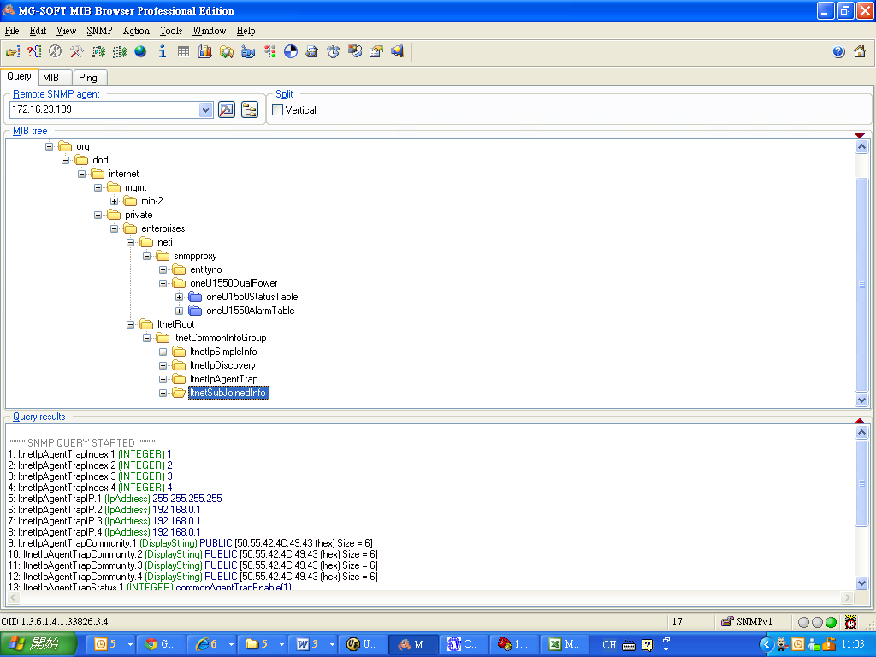

Trap Massage (LaserTemp)

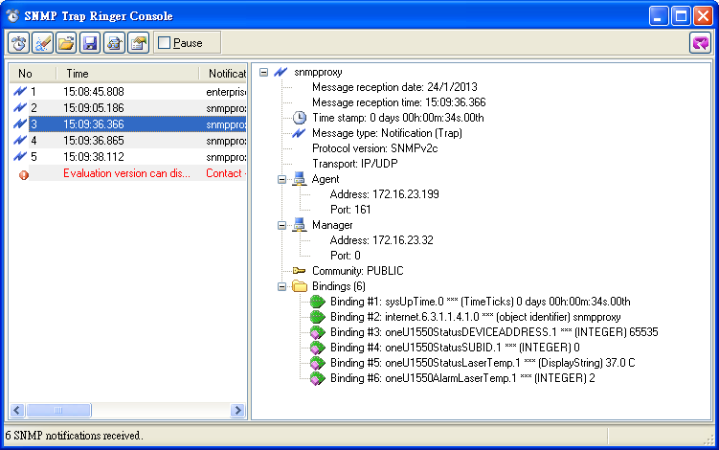
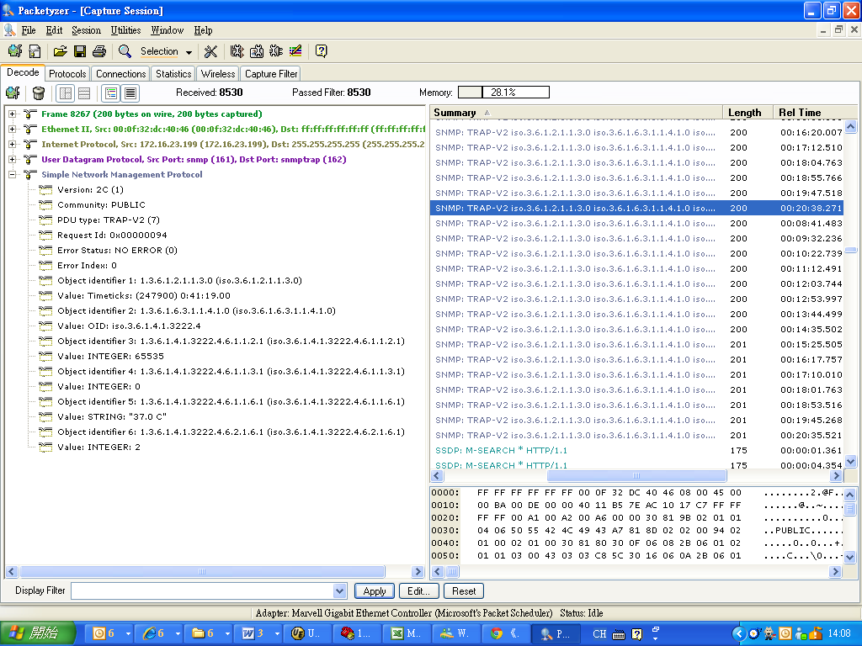

Trap Massage ( RFModLvL)

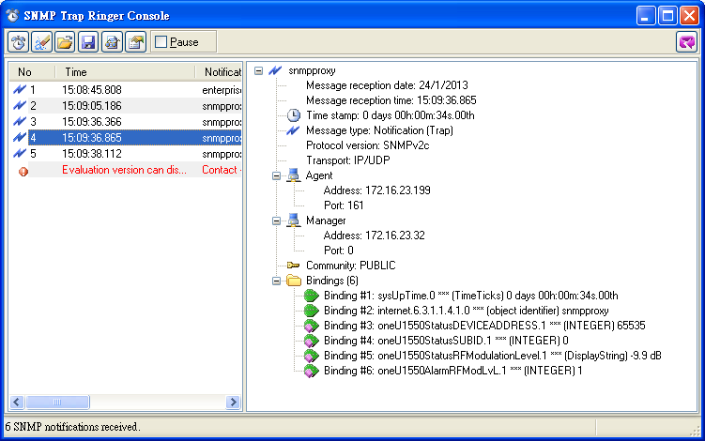

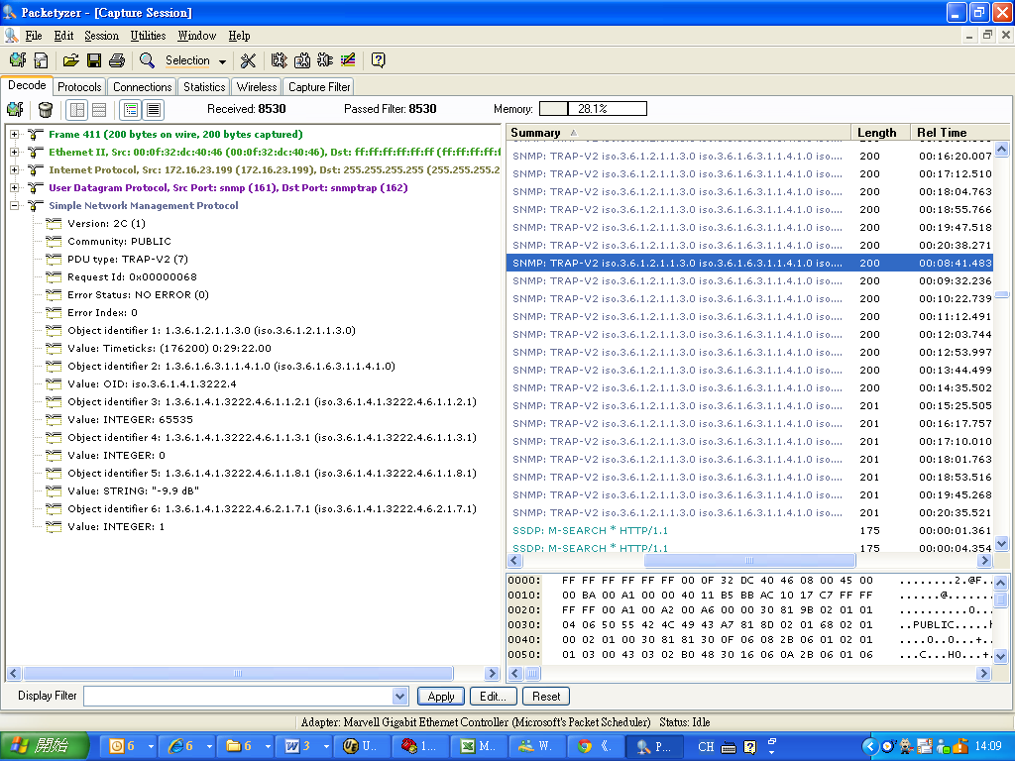

Special case: Trap Massage ( CommFail Binding #5 and Binding #6 return the same OID)

